1. Given that an EMPLOYEE class contains following members: Employee Number, Employee Name, Basic, DA, IT, Net Salary. Member functions: to read the data, to calculate Net Salary and to print data members. Write a C++ program to read the data of N employees and compute Net Salary of each employee. (Dearness Allowance (DA) = 52% of Basic and Income Tax (IT) = 30% of the gross salary. Net Salary = Basic + DA - IT).

#include <iostream>

#include <string>

using namespace std;

class employee

{

private:

string name;

int number;

float basicSalary,netSalary;

public:

void inputDetails();

void calculateNetSalary();

void displayDetails();

};

void employee::inputDetails()

{

cout<<"Employee Name : ";

cin>>name;

cout<<"Employee Number : ";

cin>>number;

cout<<"Basic Salary : ";

cin>>basicSalary;

cout<<endl;

}

void employee::calculateNetSalary()

{

float dearnessAllowance,grossSalary,incomeTax;//no need to display these, these are needed only to calculate,so not declaring in private but here

dearnessAllowance=(basicSalary*52)/100;

grossSalary=basicSalary+dearnessAllowance;

incomeTax=(grossSalary*30)/100;

netSalary=basicSalary+dearnessAllowance-incomeTax;

}

void employee::displayDetails()

{

cout<<"Employee Name : "<<name<<endl;

cout<<"Employee Number : "<<number<<endl;

cout<<"Basic Salary : "<<basicSalary<<endl;

cout<<"Net Salary : "<<netSalary<<endl<<endl;

}

int main()

{

int n;

cout<<"Input number of employees : ";

cin>>n;

employee e[n];

for(int i=0;i<n;++i)

{

cout<<"Input Employee "<<i+1<<" details : "<<endl;

e[i].inputDetails();

e[i].calculateNetSalary();

cout<<"Employee "<<i+1<<" Details are : "<<endl;

e[i].displayDetails();

}

return 0;

}

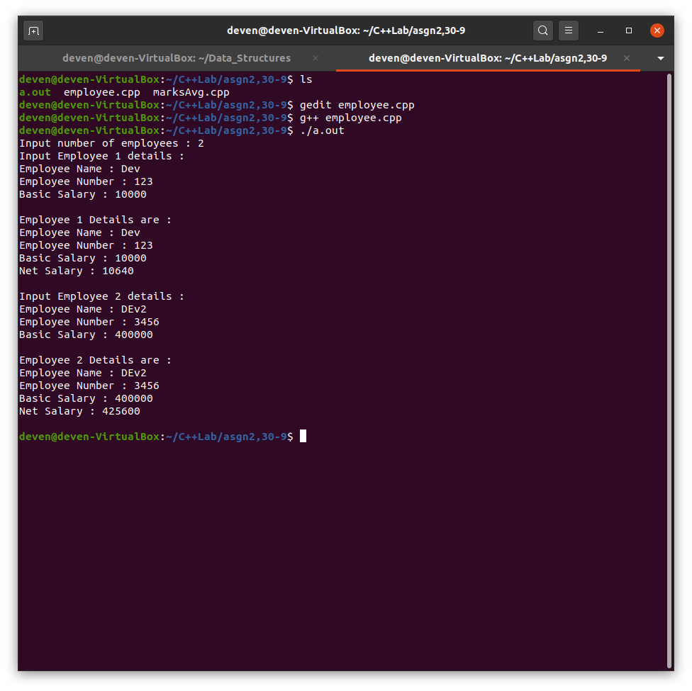

1. Write a C++ program to Create array of objects of class student with data members for storing his USN marks of six subjects for three tests and member functions to input display and calculate the avg marks for each subject taking best two of three subjects. Write a tester program to test these classes.

#include <iostream>

using namespace std;

class student

{

private:

string name;

string USN;

int marks[3][6];

float avgMarks[6];

public:

void inputDetails();

void calculateAvgMarks();

void outputDetails();

};

void student::inputDetails()

{

cout<<"Name : ";

cin>>name;

cout<<"USN : ";

cin>>USN;

for(int i=0;i<3;++i)

{

cout<<"Enter test "<<i+1<<" marks of 6 subjects in order: ";

for(int j=0;j<6;++j)

cin>>marks[i][j];

}

}

void student::outputDetails()

{

cout<<"Name : "<<name<<endl;

cout<<"USN : "<<USN<<endl;

cout<<"Average Marks : ";

for(int j=0;j<6;++j)

cout<<avgMarks[j]<<" ";

cout<<endl;

}

void student::calculateAvgMarks()

{

int subMarks1,subMarks2;

for(int i=0;i<6;++i)

{

if(marks[0][i]>=marks[1][i])

{

subMarks1=marks[0][i];

if(marks[2][i]>=marks[1][i])

subMarks2=marks[2][i];

else

subMarks2=marks[1][i];

}

else

{

subMarks1=marks[1][i];

if(marks[2][i]>=marks[0][i])

subMarks2=marks[2][i];

else

subMarks2=marks[0][i];

}

avgMarks[i]=static_cast<float>(subMarks1+subMarks2)/2;//****************

}

}

int main()

{

int n;

cout<<"Enter number of students : ";

cin>>n;

student s[n];

for(int i=0;i<n;++i)

{

cout<<"Enter the details of student "<<i+1<<endl;

s[i].inputDetails();

s[i].calculateAvgMarks();

s[i].outputDetails();

}

return 0;

}

